WT Assignment 5
Neeti Kurulkar
Java Servlet App

MySQL and Database Setup

use bookstore;

CREATE DATABASE myebookshop;
USE myebookshop;

CREATE TABLE ebookshop (
book_id INT PRIMARY KEY AUTO_INCREMENT,
book_title VARCHAR(255) NOT NULL,
book_author VARCHAR(255) NOT NULL,
book_price DECIMAL(10,2) NOT NULL,
quantity INT NOT NULL
);

INSERT INTO ebookshop (book_id, book_title, book_author, book_price, quantity) VALUES
(1, 'Computer Networks', 'Andrew S. Tanenbaum', 699.00, 10),
(2, 'Operating System Concepts', 'Abraham Silberschatz', 850.50, 5),
(3, 'Database System Concepts', 'Henry F. Korth', 799.99, 8),
(4, 'Software Engineering', 'Ian Sommerville', 599.00, 12),
(5, 'Artificial Intelligence', 'Stuart Russell', 999.00, 7),
(6, 'Machine Learning', 'Tom M. Mitchell', 899.00, 6),
(7, 'Compiler Design', 'Alfred V. Aho', 749.50, 9),
(8, 'Cloud Computing', 'Rajkumar Buyya', 670.00, 15),
(9, 'Cyber Security Essentials', 'Charles J. Brooks', 720.00, 10),
(10, 'Data Structures and Algorithms', 'Narasimha Karumanchi', 550.00, 14);

SELECT * from ebookshop;

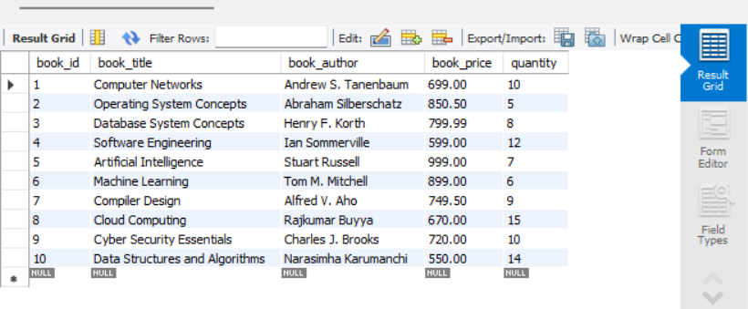

Dynamic Web Project Setup

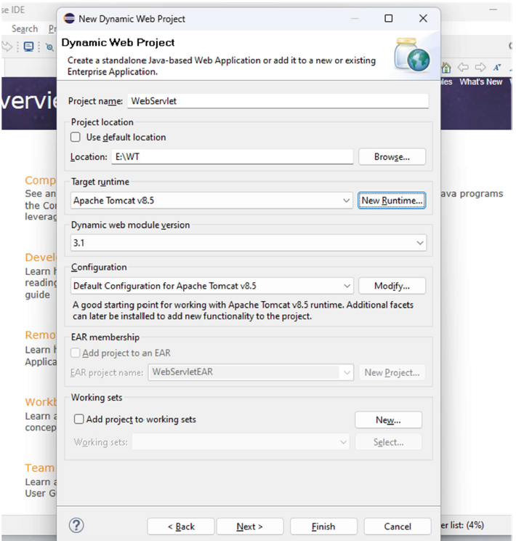
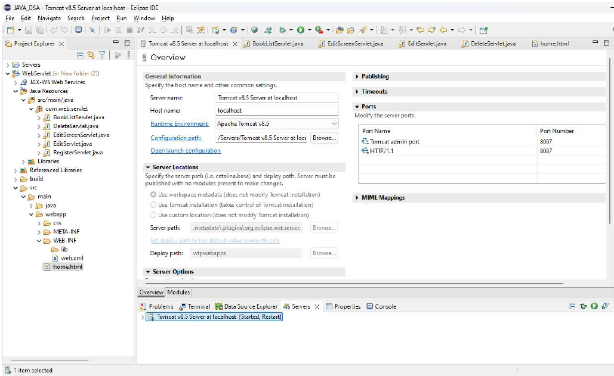
XML and HTML files

- Web.xml

<?xml version="1.0" encoding="UTF-8"?>
<web-app
xmlns:xsi="http://www.w3.org/2001/XMLSchema-instance"
xmlns="http://xmlns.jcp.org/xml/ns/javaee"
xsi:schemaLocation="http://xmlns.jcp.org/xml/ns/javaee
http://xmlns.jcp.org/xml/ns/javaee/web-app_4_0.xsd"
id="WebApp_ID"
version="4.0">

<welcome-file-list>
<welcome-file>home.html</welcome-file>
</welcome-file-list>

<display-name>BookWebApp</display-name>

</web-app>

- Home.html

<!DOCTYPE html>
<html>
<head>
<meta charset="ISO-8859-1">
<title>Book Registration</title>
<link rel="stylesheet" href="css/bootstrap.css">
<style>
body {
display: flex;
justify-content: center;
align-items: center;
height: 100vh;
background-color: #f8f9fa;
margin: 0;
}
.card {
width: 100%;
max-width: 500px;
padding: 20px;
border-radius: 10px;
box-shadow: 0 4px 8px rgba(0, 0, 0, 0.1);
background: white;
}
h2 {
padding: 10px;
border-radius: 5px;
text-align: center;
}
.btn-custom {
width: 100%;
}
a {
display: block;
text-align: center;
margin-top: 15px;
text-decoration: none;
font-weight: bold;
color: #007bff;
}
a:hover {
text-decoration: underline;
}
</style>
</head>
<body>
<div class="card">
<h2 class="bg-danger text-white">Book Registration</h2>
<form action="register" method="post">
<div class="mb-3">
<label class="form-label">Book Name</label>
<input type="text" name="bookName" class="form-control" placeholder="Enter book name" required>
</div>
<div class="mb-3">
<label class="form-label">Book Edition</label>
<input type="text" name="bookEdition" class="form-control" placeholder="Enter book edition" required>
</div>
<div class="mb-3">
<label class="form-label">Book Price</label>
<input type="number" name="bookPrice" class="form-control" placeholder="Enter book price" required min="0" step="0.01">
</div>
<div class="d-grid gap-2">
<button type="submit" class="btn btn-success btn-custom">Register</button>
<button type="reset" class="btn btn-secondary btn-custom">Cancel</button>
</div>
</form>
<a href="bookList">View Book List</a>
</div>
</body>
</html>

Java Codes

- BookListServlet.java

package com.web.servlet;

import java.io.IOException;
import java.io.PrintWriter;
import java.sql.Connection;
import java.sql.DriverManager;
import java.sql.PreparedStatement;
import java.sql.ResultSet;
import java.sql.SQLException;
import javax.servlet.ServletException;
import javax.servlet.annotation.WebServlet;
import javax.servlet.http.HttpServlet;
import javax.servlet.http.HttpServletRequest;
import javax.servlet.http.HttpServletResponse;

@WebServlet("/bookList")
public class BookListServlet extends HttpServlet {

private static final String QUERY = "SELECT BOOK_ID, BOOK_TITLE, BOOK_AUTHOR, BOOK_PRICE, QUANTITY FROM EBOOKSHOP";

@Override
protected void doGet(HttpServletRequest req, HttpServletResponse res) throws ServletException, IOException {
// Get PrintWriter
PrintWriter pw = res.getWriter();
// Set content type
res.setContentType("text/html");

// Load JDBC driver
try {
Class.forName("com.mysql.cj.jdbc.Driver");
} catch (ClassNotFoundException cnf) {
cnf.printStackTrace();
}

// Generate the connection
try (Connection con = DriverManager.getConnection("jdbc:mysql:///ebookstore", "root", "root");
PreparedStatement ps = con.prepareStatement(QUERY)) {

ResultSet rs = ps.executeQuery();

// Adding CSS styles for better table design
pw.println("<style>");
pw.println("table { width: 80%; margin: 20px auto; border-collapse: collapse; font-family: Arial, sans-serif; }");
pw.println("th, td { border: 1px solid black; padding: 10px; text-align: center; }");
pw.println("th { background-color: #f2f2f2; }");
pw.println("a { text-decoration: none; color: blue; }");
pw.println("a:hover { color: red; }");
pw.println("</style>");

pw.println("<table>");
pw.println("<tr>");
pw.println("<th>Book Id</th>");
pw.println("<th>Book Name</th>");
pw.println("<th>Book Author</th>");
pw.println("<th>Book Price</th>");
pw.println("<th>Quantity</th>");
pw.println("<th>Edit</th>");
pw.println("<th>Delete</th>");
pw.println("</tr>");

while (rs.next()) {
pw.println("<tr>");
pw.println("<td>" + rs.getInt(1) + "</td>");
pw.println("<td>" + rs.getString(2) + "</td>");
pw.println("<td>" + rs.getString(3) + "</td>");
pw.println("<td>" + rs.getFloat(4) + "</td>");
pw.println("<td>" + rs.getInt(5) + "</td>");
pw.println("<td><a href='editScreen?id=" + rs.getInt(1) + "'>Edit</a></td>");
pw.println("<td><a href='deleteurl?id=" + rs.getInt(1) + "'>Delete</a></td>");
pw.println("</tr>");
}
pw.println("</table>");

} catch (SQLException se) {
se.printStackTrace();
pw.println("<h1>" + se.getMessage() + "</h1>");
} catch (Exception e) {
e.printStackTrace();
pw.println("<h1>" + e.getMessage() + "</h1>");
}

pw.println("<br><a href='home.html'>Home</a>");
}

@Override
protected void doPost(HttpServletRequest req, HttpServletResponse res) throws ServletException, IOException {
doGet(req, res);
}
}

- EditScreenServlet.java

package com.web.servlet;

import java.io.IOException;
import java.io.PrintWriter;
import java.sql.Connection;
import java.sql.DriverManager;
import java.sql.PreparedStatement;
import java.sql.ResultSet;
import java.sql.SQLException;

import javax.servlet.ServletException;
import javax.servlet.annotation.WebServlet;
import javax.servlet.http.HttpServlet;
import javax.servlet.http.HttpServletRequest;
import javax.servlet.http.HttpServletResponse;

@WebServlet("/editScreen")
public class EditScreenServlet extends HttpServlet {
private static final String query = "SELECT book_id, book_title, book_author, book_price, quantity FROM ebookshop WHERE book_id = ?";

@Override
protected void doGet(HttpServletRequest req, HttpServletResponse res) throws ServletException, IOException {
// Get PrintWriter
PrintWriter pw = res.getWriter();
// Set content type
res.setContentType("text/html");
// Get the book ID from request parameters
int id = Integer.parseInt(req.getParameter("id"));

// Load JDBC driver
try {
Class.forName("com.mysql.cj.jdbc.Driver");
} catch (ClassNotFoundException cnf) {
cnf.printStackTrace();
}

// Generate the database connection
try (Connection con = DriverManager.getConnection("jdbc:mysql:///ebookstore", "root", "root");
PreparedStatement ps = con.prepareStatement(query)) {

ps.setInt(1, id);
ResultSet rs = ps.executeQuery();

if (rs.next()) {
pw.println("<html><head><title>Edit Book</title>");
pw.println("<link rel='stylesheet' href='css/bootstrap.css'>");
pw.println("<style>");
pw.println("body { display: flex; justify-content: center; align-items: center; height: 100vh; background-color: #f8f9fa; }");
pw.println(".card { width: 100%; max-width: 500px; padding: 20px; border-radius: 10px; box-shadow: 0 4px 8px rgba(0, 0, 0, 0.1); background: white; }");
pw.println(".btn-custom { width: 100%; }");
pw.println("</style>");
pw.println("</head><body>");
pw.println("<div class='card'>");
pw.println("<h2 class='bg-primary text-white text-center p-2'>Edit Book Details</h2>");
pw.println("<form action='editurl?id=" + id + "' method='post'>");
pw.println("<div class='mb-3'><label class='form-label'>Book Title</label>");
pw.println("<input type='text' name='bookTitle' class='form-control' value='" + rs.getString("book_title") + "' required></div>");
pw.println("<div class='mb-3'><label class='form-label'>Book Author</label>");
pw.println("<input type='text' name='bookAuthor' class='form-control' value='" + rs.getString("book_author") + "' required></div>");
pw.println("<div class='mb-3'><label class='form-label'>Book Price</label>");
pw.println("<input type='number' name='bookPrice' class='form-control' value='" + rs.getFloat("book_price") + "' required min='0' step='0.01'></div>");
pw.println("<div class='mb-3'><label class='form-label'>Quantity</label>");
pw.println("<input type='number' name='quantity' class='form-control' value='" + rs.getInt("quantity") + "' required min='0'></div>");
pw.println("<div class='d-grid gap-2'>");
pw.println("<button type='submit' class='btn btn-success btn-custom'>Update</button>");
pw.println("<a href='bookList' class='btn btn-secondary btn-custom'>Cancel</a>");
pw.println("</div>");
pw.println("</form>");
pw.println("</div>");
pw.println("</body></html>");
} else {
pw.println("<h2 class='text-center text-danger'>Book not found</h2>");
}
} catch (SQLException se) {
se.printStackTrace();
pw.println("<h1>" + se.getMessage() + "</h1>");
} catch (Exception e) {
e.printStackTrace();
pw.println("<h1>" + e.getMessage() + "</h1>");
}
}

@Override
protected void doPost(HttpServletRequest req, HttpServletResponse res) throws ServletException, IOException {
doGet(req, res);
}
}

- EditServlet.java

package com.web.servlet;

import java.io.IOException;
import java.io.PrintWriter;
import java.sql.Connection;
import java.sql.DriverManager;
import java.sql.PreparedStatement;
import java.sql.SQLException;

import javax.servlet.ServletException;
import javax.servlet.annotation.WebServlet;
import javax.servlet.http.HttpServlet;
import javax.servlet.http.HttpServletRequest;
import javax.servlet.http.HttpServletResponse;

@WebServlet("/editurl")
public class EditServlet extends HttpServlet {
private static final String query = "UPDATE ebookshop SET book_title=?, book_author=?, book_price=?, quantity=? WHERE book_id=?";

@Override
protected void doGet(HttpServletRequest req, HttpServletResponse res) throws ServletException, IOException {
// Get PrintWriter
PrintWriter pw = res.getWriter();
// Set content type
res.setContentType("text/html");

// Get the book ID from request parameters
int id = Integer.parseInt(req.getParameter("id"));

// Get the edited book details
String bookTitle = req.getParameter("bookTitle");
String bookAuthor = req.getParameter("bookAuthor");
float bookPrice = Float.parseFloat(req.getParameter("bookPrice"));
int quantity = Integer.parseInt(req.getParameter("quantity"));

// Load JDBC driver
try {
Class.forName("com.mysql.cj.jdbc.Driver");
} catch (ClassNotFoundException cnf) {
cnf.printStackTrace();
}

// Generate the database connection
try (Connection con = DriverManager.getConnection("jdbc:mysql:///ebookstore", "root", "root");
PreparedStatement ps = con.prepareStatement(query)) {

ps.setString(1, bookTitle);
ps.setString(2, bookAuthor);
ps.setFloat(3, bookPrice);
ps.setInt(4, quantity);
ps.setInt(5, id);

int count = ps.executeUpdate();

// HTML Response with Bootstrap styling
pw.println("<html><head><title>Edit Confirmation</title>");
pw.println("<link rel='stylesheet' href='css/bootstrap.css'>");
pw.println("<style>");
pw.println("body { display: flex; justify-content: center; align-items: center; height: 100vh; background-color: #f8f9fa; }");
pw.println(".card { width: 100%; max-width: 500px; padding: 20px; border-radius: 10px; box-shadow: 0 4px 8px rgba(0, 0, 0, 0.1); background: white; }");
pw.println(".btn-custom { width: 100%; }");
pw.println("</style>");
pw.println("</head><body>");
pw.println("<div class='card text-center'>");

if (count == 1) {
pw.println("<h2 class='text-success'>Record Updated Successfully</h2>");
} else {
pw.println("<h2 class='text-danger'>Failed to Update Record</h2>");
}

pw.println("<div class='d-grid gap-2 mt-3'>");
pw.println("<a href='bookList' class='btn btn-primary btn-custom'>Go to Book List</a>");
pw.println("<a href='home.html' class='btn btn-secondary btn-custom'>Home</a>");
pw.println("</div>");
pw.println("</div>");
pw.println("</body></html>");
} catch (SQLException se) {
se.printStackTrace();
pw.println("<h1>Error: " + se.getMessage() + "</h1>");
} catch (Exception e) {
e.printStackTrace();
pw.println("<h1>Error: " + e.getMessage() + "</h1>");
}
}

@Override
protected void doPost(HttpServletRequest req, HttpServletResponse res) throws ServletException, IOException {
doGet(req, res);
}
}

- DeleteServlet.java

package com.web.servlet;

import java.io.IOException;
import java.io.PrintWriter;
import java.sql.Connection;
import java.sql.DriverManager;
import java.sql.PreparedStatement;
import java.sql.SQLException;

import javax.servlet.ServletException;
import javax.servlet.annotation.WebServlet;
import javax.servlet.http.HttpServlet;
import javax.servlet.http.HttpServletRequest;
import javax.servlet.http.HttpServletResponse;

@WebServlet("/deleteurl")
public class DeleteServlet extends HttpServlet {
private static final String query = "DELETE FROM ebookshop WHERE book_id=?";

@Override
protected void doGet(HttpServletRequest req, HttpServletResponse res) throws ServletException, IOException {
// Get PrintWriter
PrintWriter pw = res.getWriter();
// Set content type
res.setContentType("text/html");

// Get the book ID from request parameters
int id = Integer.parseInt(req.getParameter("id"));

// Load JDBC driver
try {
Class.forName("com.mysql.cj.jdbc.Driver");
} catch (ClassNotFoundException cnf) {
cnf.printStackTrace();
}

// Generate the database connection
try (Connection con = DriverManager.getConnection("jdbc:mysql:///ebookstore", "root", "root");
PreparedStatement ps = con.prepareStatement(query)) {

ps.setInt(1, id);
int count = ps.executeUpdate();

// HTML Response with Bootstrap styling
pw.println("<html><head><title>Delete Confirmation</title>");
pw.println("<link rel='stylesheet' href='css/bootstrap.css'>");
pw.println("<style>");
pw.println("body { display: flex; justify-content: center; align-items: center; height: 100vh; background-color: #f8f9fa; }");
pw.println(".card { width: 100%; max-width: 500px; padding: 20px; border-radius: 10px; box-shadow: 0 4px 8px rgba(0, 0, 0, 0.1); background: white; }");
pw.println(".btn-custom { width: 100%; }");
pw.println("</style>");
pw.println("</head><body>");
pw.println("<div class='card text-center'>");

if (count == 1) {
pw.println("<h2 class='text-success'>Record Deleted Successfully</h2>");
} else {
pw.println("<h2 class='text-danger'>Failed to Delete Record</h2>");
}

pw.println("<div class='d-grid gap-2 mt-3'>");
pw.println("<a href='bookList' class='btn btn-primary btn-custom'>Go to Book List</a>");
pw.println("<a href='home.html' class='btn btn-secondary btn-custom'>Home</a>");
pw.println("</div>");
pw.println("</div>");
pw.println("</body></html>");
} catch (SQLException se) {
se.printStackTrace();
pw.println("<h1>Error: " + se.getMessage() + "</h1>");
} catch (Exception e) {
e.printStackTrace();
pw.println("<h1>Error: " + e.getMessage() + "</h1>");
}
}

@Override
protected void doPost(HttpServletRequest req, HttpServletResponse res) throws ServletException, IOException {
doGet(req, res);
}
}

- RegisterServlet.java

package com.web.servlet;

import java.io.IOException;
import java.io.PrintWriter;
import java.sql.Connection;
import java.sql.DriverManager;
import java.sql.PreparedStatement;
import java.sql.SQLException;

import javax.servlet.ServletException;
import javax.servlet.annotation.WebServlet;
import javax.servlet.http.HttpServlet;
import javax.servlet.http.HttpServletRequest;
import javax.servlet.http.HttpServletResponse;

@WebServlet("/register")
public class RegisterServlet extends HttpServlet {
private static final String query = "INSERT INTO ebookshop(book_title, book_author, book_price, quantity) VALUES(?,?,?,?)";

@Override
protected void doGet(HttpServletRequest req, HttpServletResponse res) throws ServletException, IOException {
// Get PrintWriter
PrintWriter pw = res.getWriter();
// Set content type
res.setContentType("text/html");

// Get the book info from request parameters
String bookTitle = req.getParameter("bookTitle");
String bookAuthor = req.getParameter("bookAuthor");
float bookPrice = Float.parseFloat(req.getParameter("bookPrice"));
int quantity = Integer.parseInt(req.getParameter("quantity"));

// Load JDBC driver
try {
Class.forName("com.mysql.cj.jdbc.Driver");
} catch (ClassNotFoundException cnf) {
cnf.printStackTrace();
}

// Generate the connection
try (Connection con = DriverManager.getConnection("jdbc:mysql:///ebookstore", "root", "root");
PreparedStatement ps = con.prepareStatement(query)) {

ps.setString(1, bookTitle);
ps.setString(2, bookAuthor);
ps.setFloat(3, bookPrice);
ps.setInt(4, quantity);
int count = ps.executeUpdate();

if (count == 1) {
pw.println("<h2>Record is Registered Successfully</h2>");
} else {
pw.println("<h2>Record Not Registered Successfully</h2>");
}
} catch (SQLException se) {
se.printStackTrace();
pw.println("<h1>" + se.getMessage() + "</h1>");
} catch (Exception e) {
e.printStackTrace();
pw.println("<h1>" + e.getMessage() + "</h1>");
}

pw.println("<a href='home.html'>Home</a>");
pw.println("<br>");
pw.println("<a href='bookList'>Book List</a>");
}

@Override
protected void doPost(HttpServletRequest req, HttpServletResponse res) throws ServletException, IOException {
doGet(req, res);
}
}

Output

